General Infomation

Legal name and registered seat of the company:

Heneken Conductors, s.r.o.
(until 12.01.2022 Heneken Conductors, a.s., until 24.02.2021 Laná, a. s.)
Prievozská 4/A

Bratislava - mestská časť Ružinov 821 09

Optional information
The company Heneken Conductors, s.r.o. (hereinafter referred to as the “Company”), was established on December 7, 2010 by the transformation of the company Laná, s.r.o., Žiar nad Hronom. It was founded by the articles of association dated June 20, 2000, according to §28, 105 et seq. Act no. 513/91 Coll.

The Company was registered in the Business Register (Business Register of the City Court Bratislava III, Section Sa , file 157846/B).

The principal activities of the Company comprise:

- purchase of goods for the purpose of selling them to other business operators (wholesale) within the scope of free trade
- purchase and sale of products made of aluminum, its alloys, other non-ferrous metals and steel
- metalworking - production of products from aluminium, its alloys, other non-ferrous metals and steel - by forming and processing of products from aluminium, its alloys, other non-
ferrous metals and steel - by forming, welding and surface treatment
- purchase of goods for the purpose of selling them to the final consumer (retail) in the scope of free trade
– production of electric motors, switchboards, cables and batteries
– research and development in the field of natural and technical sciences

Information on unlimited liability

The Company is not a partner with unlimited liability in other companies according to Article 56 (5) of the Commercial Code or similar provisions of other legislation.

Date of approval of the Financial Statements for the preceding accounting period

The Financial Statements of the Company as of 31 December 2022, i.e., for the preceding accounting period, were approved by the shareholders at the Company's general meeting on 26 April 2023.

The legal reason for the preparation of the Financial Statements

The Financial Statements of the Company as of 31 December 2023 have been prepared as for ordinary financial statements by Article 17 (6) of Act of the National Council of the Slovak Republic No. 431/2002 Coll. on Accounting (hereafter referred to as the "Act on Accounting") for the accounting period from 1 January 2023 to 31 December 2023.

The Financial Statements are intended for users who possess adequate knowledge of business and economic activities and bookkeeping and who analyze this information with appropriate care. The Financial Statements do not, and cannot, provide all information that may be needed by existing and potential investors, providers of credits and loans, and other creditors. These users must obtain relevant information from other sources.

Information on the Group

The Company is included in the Consolidated Financial Statements of the company Heneken, s.r.o.
The Consolidated Financial Statements can be obtained directly at the registered office of Heneken, s.r.o., Prievozská 4/A 821 09 Bratislava.

Number of employees

The average recalculated number of employees of the Company were 53,9 in the accounting period of 2023 (35 in the accounting period 2022).

As of 31 December 2023, the number of employees was 58, including 11 managers (as of 31 December 2022, the number of employees was 43 including 8 managers).

Auditor Approval

The General Assembly on 04 September 2023 approved the company VGD SLOVAKIA, s.r.o. as an auditor to verify the financial statements for the accounting period from January 1, 2023 to December 31, 2023.

INFORMATION ON THE AUTHORITIES OF THE ACCOUNTING Entity

Directors: Mgr. Michal Hudoba
Ing. Adrián Stolár

Shareholders: Heneken, s.r.o.
Ing. Peter Gönczöl

Authorized signatory: Ing. Peter Gönczöl

Information about the shareholders of The ACCOUNTING Entity

From the February 2nd, 2023 the structure of the company’s shareholders was following:

Shareholder | Interest in share capital |  | Voting rights in %
Shareholder | In absolut terms | In % | Voting rights in %
a | b | c | d
Heneken, s.r.o. | 1 800 758 | 94% | 94%
Ing. Peter Gönczöl | 114 942 | 6% | 6%
Total in EUR | 1 915 700

As of February 2, 2023, the parent company Heneken, s.r.o. bought a 5% share from Samco s.r.o. and its share on an underlying basis from 88% to 94%. The amount of the share capital remained unchanged and has a value of 1 915 700 EUR

Information on the applied procedures

- Basis of preparation of financial statements

The Financial Statements have been prepared using the going concern assumption.
On the side of suppliers or customers, the Company has no partners in Ukraine, Belarus or Russia. The unstable situation on the gas market, primarily natural gas imported from Russia, had an impact on the increase in the capacities of the electrical network and greater demand for the Company's products (Laná).

- Non-current intangible assets and property, plant and equipment

Purchased non-current assets are valued at their acquisition cost, which consists of the price at which an asset has been acquired plus costs related to the acquisition (customs duty, transport, assembling costs, insurance etc.)

Part of the purchase price of a non current are not interest on loans incurred before the non current asset is put into use.

Non current assets created by own activity are valued at own costs. Own costs are all direct costs incurred for production or other activity and indirect costs that apply to production or other activity.

Development costs are capitalized if their amount does not exceed the amount that is likely to be obtained from future economic benefits after deducting other development, selling and administrative costs directly related to marketing or processes. Capitalized development costs are depreciated over a maximum of five years. If the possibility of capitalization of development costs is not proven, they are booked to costs in the accounting period in which they were incurred.

Amortization of non current intangible assets is determined based on the expected period of its use and the expected course of its wear and tear.

Estimated useful life, depreciation method and depreciation rate are shown in the following table:

 |  | Account |  | Estimated useful life in years | Amortization method |  | Annual rate of amortization in %
Software |  | 13 |  | 5 | Straight-line |  | 20
Industrial buildings |  | 21 |  | 25 | Straight-line |  | 4
Other machines - electric furnace  (ALMAMATER) |  | 22 |  | 12 | Straight-line |  | 8
Other machines – twine machine, rewinder,  tearing device 22 |  |  |  | 10 | Straight-line |  | 10
Other machines – technology for the production  of ropes and wires from AL 22 |  |  |  | 40 | Straight-line |  | 3
Transport facilities 23 |  |  |  | 4 | Straight-line |  | 25

Amortization methods, useful lives, and carrying values are reviewed as of each balance sheet date and adjusted if appropriate.

Depreciation of non current tangible assets is based on the estimated useful life of the asset and its expected wear and tear.

During the year 2022, the Company revised the amortization schedule for the aluminum rope and wire manufacturing technology from the original 20 years to 40 years. Metal drums were also transferred from long-term tangible assets to inventories.

Impairment review

Value adjustments are created based on the prudence principle if it is justified to assume that the value of an asset has decreased compared to its carrying value. A value adjustment is recognized in the amount of the justified estimate of the impairment of the asset compared to its carrying value
Factors that are considered important for a review of asset impairment include:
- technological advances;
- significant underperformance relative to historical or projected future operating results;
- significant changes in the manner of use of the Company assets or an overall change in the Company strategy;
- products obsolescence.

If the Company determines that, based on the existence of one or several asset impairment indicators, it can be assumed that the value of an asset has decreased compared to its carrying value, it calculates the asset impairment on the basis of estimates of projected net discounted cash flows that are expected from the asset, including its possible sale. The estimated impairment could prove insufficient if the analysis overestimated cash flows or if conditions change in the future.

- Inventory

Inventory is valued at acquisition price (purchased inventories) or own costs (inventory created by own activities).
Acquisition cost includes the price at which inventory has been acquired plus costs related to the acquisition (customs duty, transport, insurance, commissions, etc.)

Decrease in inventory is accounted for at stock prices. Monthly discounts on the amount of paper purchased are charged to a separate analytical account. These price variations dissolve on a monthly basis depending on the increase and decrease of these stocks.

Conversion cost includes direct costs (direct material, direct labor, and other direct costs) and part of indirect costs directly related to own work capitalized (production overheads).

Inventory is written down for any impairment of value.

- Receivables

Receivables are initially measured at their nominal value; assigned receivables and receivables acquired via a contribution to share capital are valued at their acquisition cost, including costs related to the acquisition. The valuation of receivables is reduced by doubtful and bad debts.

- Own shares and own business shares

Own shares and own business interests are valued at the purchase price. A reserve fund is created in equity for own shares and own business shares.

- Financial accounts

Financial accounts are comprised of cash, stamps and vouchers, and bank account balances and are valued at their nominal value. A value adjustment is created for any impairment.

- Deferred expenses and deferred income

Deferred expenses and deferred income are recognized in the amount necessary to comply with the principle of material and temporal connection with the accounting period.

- Asset impairment and value adjustments

Value adjustments are created based on the prudence principle if it is justified to assume that the value of an asset has decreased compared to its carrying value. The value adjustment is accounted for in the amount of the justified estimate of the impairment of the asset compared to its carrying value. Value adjustments are reversed or their amount is changed if the assumption of impairment changes.

Impairment of non-current assets and inventory
As of each balance sheet date, the carrying value of the Company's assets other than a deferred tax asset is reviewed to determine whether there are any indicators that assets may be impaired. If such indicators exist, the expected future economic benefits from the relevant asset are estimated.

Value adjustments presented in previous periods are reassessed as of each balance sheet date to determine whether any indicators exist that the asset impairment assumption has changed or ceased to exist. A value adjustment is reversed if the assumptions used for determining the expected economic benefits from the asset have changed. A value adjustment is only reversed to the extent that the carrying value of the asset does not exceed the carrying value that would have been determined, net of amortization and depreciation, if the value adjustment had not been presented.

- Liabilities

Liabilities are initially measured at their nominal value. Assumed liabilities are valued at their acquisition cost. If reconciliation procedures reveal that the actual amount of liabilities differs from the amount recorded in the accounting books, the actual amount is used to value these liabilities in the accounting books and financial statements.

- Provisions

A provision is a liability representing the Company's existing obligation arising from past events, which is likely to reduce its economic benefits in the future. Provisions are liabilities of uncertain timing or amount and are valued on the basis of an estimate whose amount is necessary to fulfill the existing obligation as of the balance sheet date.

The creation of a provision is recorded in the relevant expense or asset account to which the liability is attributable. The use of the provision is debited to the relevant account of provisions with a corresponding credit entry in the relevant liability account. Reversal of an unusable provision or part thereof is accounted for by means of an accounting entry in reverse to the creation of the provision.

The creation of a provision for bonuses, rebates, discounts, and the repayment of the purchase price in the event of a complaint is recorded as a reduction in the originally earned income with a corresponding credit entry in the account of provisions.

Provision for warranty repairs

Due to insignificance, the reserve for warranty repairs in 2023 was not created for the expected costs of warranty repairs of products that were sold in 2023. The company retained the long-term part of the reserve at a fair value of 5 462 EUR. Based on historical knowledge and experience, it is not likely that this reserve will be used.

- Deferred tax

Deferred taxes (deferred tax assets and deferred tax liabilities) relate to the following:
- temporary differences between the carrying value of assets and the carrying value of liabilities presented in the Balance Sheet and their tax base;
- tax losses which are possible to carry forward to future periods, being understood as the possibility of deducting these tax losses from the tax base in the future;
- unused tax deductions and other tax claims which are possible to carry forward to future periods.

Deferred tax assets and deferred tax liabilities are not recognized in the following cases:
- temporary differences upon initial recognition of an asset or liability in the accounting books if this accounting transaction has no impact on profit/loss or the tax base at the time of initial recognition and, at the same time, does not involve a business combination (i.e., it is not an accounting transaction arising for the buyer in the event of the purchase of a business or part thereof, the recipient of a contribution of a business or part thereof, or the successor accounting entity in the event of a merger, amalgamation into a separate accounting entity or demerger);
- temporary differences related to investments in subsidiaries, jointly controlled accounting entities, and associated accounting entities to the extent that the Company is able to control the timing of the reversal of the temporary differences and it is probable that they will not reverse in the foreseeable future;
- temporary differences upon initial recognition of goodwill or negative goodwill.

A deferred tax asset related to deductible temporary differences, unused tax losses, and unused tax deductions and other tax claims is only recognized if it is probable that a taxable profit will be available against which these amounts can be utilized. A deferred tax asset is reviewed as of each balance sheet date and reduced by the amount in which it is not probable that a taxable profit will be attained.
Deferred tax is measured at the tax rates that are expected to be applied to the temporary differences when they reverse.

A deferred tax asset and a deferred tax liability are presented separately in the Balance Sheet. If they relate to deferred income tax with respect to the same taxable entity and the same taxation authority, it is possible to only present the final balance of account 481 – Deferred tax liability and deferred tax asset.
- Deferred expenses and deferred income

Deferred expenses and deferred income are recognized in the amount necessary to comply with the principle of material and temporal connection with the accounting period.

- Subsidies from the state budget

An entitlement to a subsidy from the state budget shall be accounted for if it is virtually certain that the entity will comply with the conditions attached to the subsidy and that the subsidy will be received.

Subsidies for the Company’s operations are initially recorded as deferred income and are released into operating revenue in relation to the recognition of expenses incurred for the purpose for which subsidies for operations have been granted.

The Company was approved for a non-refundable financial contribution for the procurement of technologies in the amount of 2,018.350 EUR, which represents 50% of the total authorized expenses for the realization of project assets - Introduction of innovative and advanced technologies in the production of aluminum-based wires and conductors, in accordance with the agreement on the provision of non-refundable financial support contribution /hereinafter "NFP"/no. KaHR-111SP-1201/0732/130, which entered into force on February 1, 2014.

Technology for the production of aluminum-based ropes and conductors 4,147.157 EUR
Price increase (procurement costs) 101.050 EUR
The share of the subsidy is 47.51%

- Foreign currency

Assets and liabilities denominated in a foreign currency are translated to the euro currency as of the date of the accounting transaction according to the foreign exchange reference rate determined and announced by the European Central Bank or the National Bank of Slovakia on the date preceding the date of the accounting transaction (hereafter referred to as the "reference rate").

An increase in a foreign currency purchased with the euro currency is valued according to the exchange rate at which this foreign currency was purchased. (except for the value of foreign currency procured as part of a currency derivative)

An increase in a foreign currency (except for the value of foreign currency procured as part of a currency derivative) purchased for another foreign currency, the value of another foreign currency in euros is used, or to value the increase in foreign currency in euros, the reference exchange rate on the day of the transaction is used.

For the valuation of foreign currency procured as part of a currency derivative
• if the contracting party is a bank or branch of a foreign bank, the exchange rate of the bank or branch of the foreign bank that is a contracting party to this currency derivatived or the reference exchange rate on the valuation date is used,
• if the contracting party is not a bank or a branch of a foreign bank, the reference exchange rate on the day of the valuation is used

Received and provided advances in a foreign currency through an account maintained in this foreign currency are converted to euro at the reference exchange rate determined and announced by the European Central Bank or the National Bank of Slovakia on the day preceding the day of the accounting event.
Received and provided advances in foreign currency to and from an account established in euros are converted to the euro currency at the exchange rate at which these values were purchased or sold.

They are no longer restated as at the balance sheet date.

Assets and liabilities denominated in foreign currencies (excluding advances received and provided) are converted into euros at the reference date determined and announced by the European Central Bank or the National Bank of Slovakia on the date on which the financial statements is prepared and is accounted for with an impact on profit or loss.

- Revenue

Revenue from own work and merchandise is net of value added tax. Revenue is also reduced by discounts and reductions (rebates, bonuses, quick payment discounts, credit notes, etc.), irrespective of whether a customer was entitled to a discount in advance or whether a discount was agreed upon subsequently.

Revenue from the sale of products and merchandise is recognized on the date of performance of a supply according to the Commercial Code, Incoterms, or other terms and conditions specified in the contract.

Revenue from the sale of services is recognized in the accounting period in which the services were provided. Interest income is recorded evenly in the accounting periods to which it relates in terms of substance and time.

- Comparative information

The information in the financial statements are comparable.
In 2023, the reporting of loans as part of equity participation was adjusted in the statements. For the sake of comparability, the comparable period was adjusted accordingly. It concerns the following balance sheet lines:

- Correction of prior periods errors

If the Company identifies a significant error concerning previous accounting periods during the current accounting period, it corrects this error in accounts 428 - Retained earnings from previous years and 429 - Accumulated losses from previous years, i.e., with no impact on net profit/loss of the current accounting period. Corrections of insignificant errors of previous accounting periods are recorded in the current accounting period in the relevant expense or income account.

In 2023, the Company did not account for the correction of significant errors of past periods.

Information on Balance sheet items

Property, plant and equipment

Information on the movements of property, plant and equipment from 1 January 2023 to 31 December 2023 and for the comparative period from 1 January 2022 to 31 December 2022 is shown in the tables on pages 8 and 9

Property, plant and equipment acquired by purchase - at their acquisition price. Acquistition price ist the price at which
acquired the property including the costs related to its acquisition (shipping and customs duties).

In the year 2023, the Company records a lien on Property, plant and equipment with a residual value of 3 180 527 EUR.

An overview is given in the table below:
 | Current period
Land | 79 201
Structures | 355 174
Individual movable assets and sets of movable assets | 2 746 152
Total: | 3 180 527

Non-current intangible assets

Information on the movements of non-current intangible assets from 1 January 2023 to 31 December 2023 and for the comparative period from 1 January 2022 to 31 December 2022 is shown in the tables on pages 10 and 11. Non-current intangible and tangible assets acquired in another way- valued at fair value in the case of free acquisition of assests or assets identified in a stock - taking.
In 2023, the Company does not have any non-current intangible assets subject to the right of lien and other restrictions (no such assets in 2022).
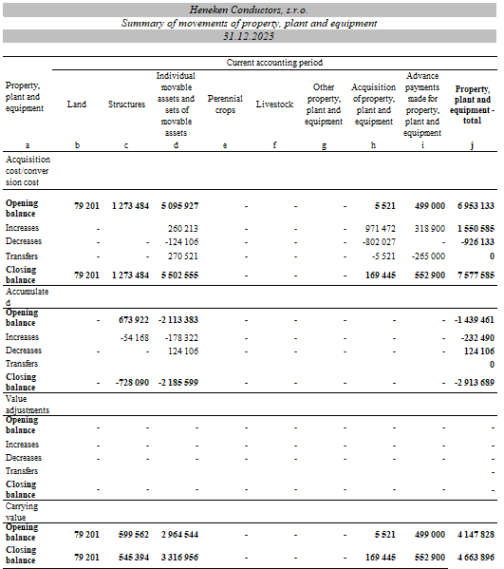

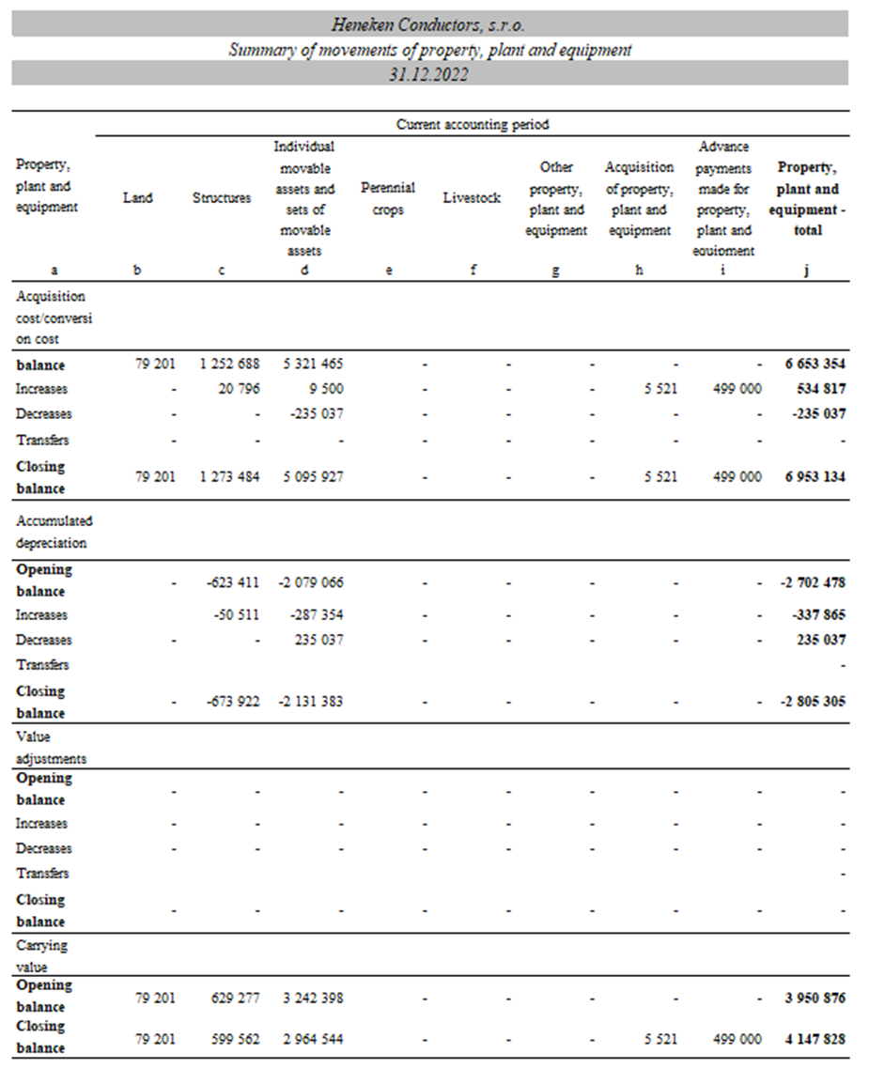

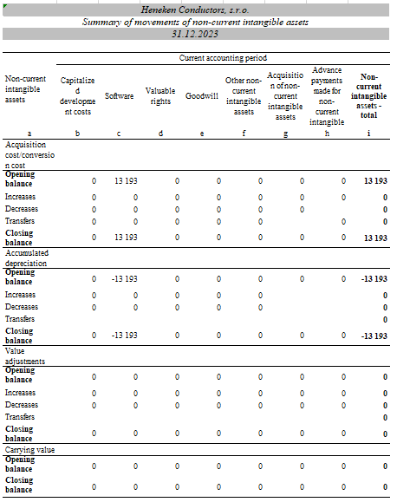

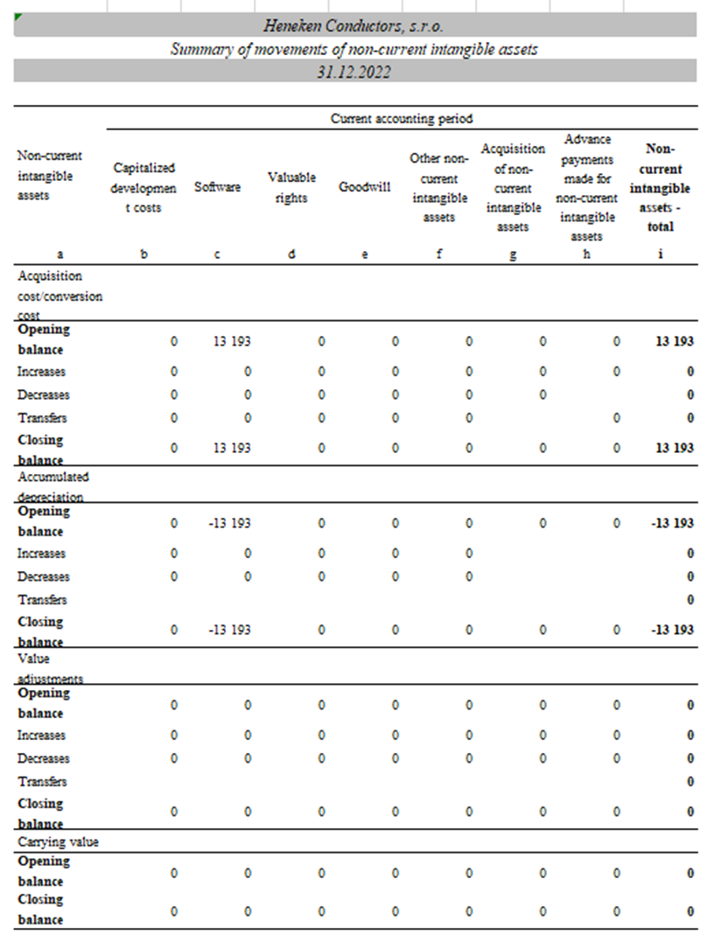

Inventory

The Company did not identify an increase in the derived value of the inventory, therefore did not created any value adjustment.

The Company registers inventory on which a lien has been placed. More information can be found in point 12.

Receivables

The Company did not identify an increase in the derived value of receivables, therefore did not created any value adjustment.

The ageing structure of receivables as of 31. December 2023 is presented in the table below:

The ageing structure of receivables as of 31. December 2022 is presented in the table below:

The structure of receivables according to the residual maturity period is shown in the following overview:

Financial accounts

Cash on hand, bank accounts and valuables are reported as financial accounts. The bank accounts are at the Company's full disposal,

Accruals

Accruals include the following items:

Equity

As of 31 December 2023, the Company’s share capital amounts to 1 915 700 EUR (as of 31 December 2022: EUR 1 915 700 EUR)

The share capital was repaid in full.

The accounting profit for 2022 in the amount of 847 201 EUR was settled as follows:

The general meeting will decide on the distribution of profit in the amount of 1 892 429,35 EUR for the accounting period 2023.

The proposal of the statutory body to the general meeting will be the transfer of part of the profit to retained earnings of previous periods and part of the profit will be used to pay dividends to shareholders.

Mandatory allocation to the legal reserve fund is not necessary, as the legal reserve fund has already reached its maximum limit set by legislation and the articles of association

Provisions

Provisions for the current accounting period are shown in the table below:

The provision for warranty repairs was not created in 2023. This results from the reassessment of the creation of the provision for warranty repairs and almost no complaints in 2023. The Company kept a long-term part of the provision for warranty repairs. The provision for unused vacation has not been created. A provision for audit and verification of financial statements has been created.

Provisions for the previous accounting period are shown in the table below:

Liabilities

Liabilities (except for bank loans) according to maturity are shown in the table below:

Deferred tax liability

The calculation of the deferred tax liability and the change booked through the profit and loss statement is shown in the following overview:

Social fund

The creation and drawing from the social fund during the accounting period are presented in the table below:

According to the Act on the Social Fund, part of the social fund must be created against expenses and part can be created from retained earnings. According to the Act on the Social Fund, the social fund is used to satisfy social, health, recreation, and other needs of employees.

Bank loans

The structure of bank loans is shown in the following overview:

The structure of bank loans according to the residual maturity period is shown in the following overview:

Liabilities secured by a lien

Overdraft loans at UNCB, a.s.

Lien on property no. 35/2017/2 on title deed no. 2677 conducted for the district of Žiar nad Hronom, cadastral territory of Horné Opatovce on title deed no. 872, cadastral territory of Ladomerská Vieska.

 |  | Lien
Bank loan - overdraft - UNCB |  | Inventory, receivables
Bank loan - overdraft - UNCB |  | Inventory, receivables, construction and land in ŽnH
Bank loan - technology - SLSP |  | Technology
Bridging loan - SLSP |  | without lien
Bridging loan - SLSP |  | without lien
Other short-term loan - UNCB |  | Inventory, receivables
Bridging loan - SLSP |  | without lien
Project financing – UNCB |  | Inventory, receivables, EIB 50 %

Borrowings and repayable financial assistance

During 2023, the company repaid the loan for capital strengthening from the company Heneken, s.r.o. in the amount of 200 thousand EUR.

Accruals

The structure of accruals/deferrals is presented in the table below:

Information on Income taxes

A reconciliation from the theoretical income tax to the reported income tax is shown in the table below:

Other information about deferred taxes:

The income tax rate in the Slovak Republic is 21% (in 2022: 21%).

Information on Profit and loss statement

Revenue from own work and merchandise

Revenue from own work and merchandise according to the individual segments, i.e., types of products and services, is presented in the table below:

Changes in internal inventory

The change in internal inventory presented in the income statement represents an increase in the amount of 1 332 941 EUR.
(2022: an increase in the amount of 2 657 EUR )

Capitalized costs, other operating income, financial income and extraordinary income

Overview of capitalized costs, other operating income, financial income and extraordinary income is presented in the table below:

Other operating and financial income

Expenses related to provided services

Expenses related to auditor, audit company

Audit and consultancy costs include the costs for the verification of the financial statements by the auditing company and other services provided by this company in the following overview

Personnel expenses

Other operating expenses

Financial expenses

Net turnover

Classification of net turnover according to Article 2 (15) of the Act on Accounting according to individual types of products, merchandise and services or other activities of the accounting entity and main geographical markets:

Information on off-Balance sheet assets and off-balance sheet liabilities

Contingent liabilities

The company Heneken Conductors, s.r.o. is the guarantor of overdraft loans of the parent company Heneken, s.r.o.

Information on events occuring between the balance sheet date and the date of preparation of the financial statements

On March 11, 2024, the Company became a guarantor for the return of funds provided by the creditor, which is the Export-Import Bank of the Slovak Republic, in favor of the debtor, which is the parent company Heneken, s.r.o. In the event that any payable obligations are not satisfied by the parent company Heneken, s.r.o. towards the creditor, the Company undertakes to satisfy payable obligations up to EUR 4,000,000 or EUR 1,275,000.

In addition to the above, after December 31, 2023, no events occurred that had a significant impact on the fair presentation of the facts of the company's financial statements.

Information on the accounting ENTITY'S Transactions with related parties

Parties related to the Company include shareholders, members of the board of directors, sister companies and companies in which the share in the share capital exceeds 20% (subsidiaries and associated companies and joint ventures).

- Transactions with joint accounting entities:

The Company carried out the following transactions with joint accounting entities:

Heneken, s.r.o

Heneken Melts, s.r.o

- Transactions with key management personnel

Key management personnel are persons having authority and responsibility for planning, directing, and controlling the activities of the accounting entity, directly or indirectly, including any executive director or another director of that accounting entity. The average number of key management personnel was 11 in 2023 and 8 in 2022.

No emoluments or benefits or other significant payments have been provided to key management .

- Transactions with other related parties

INformation on Payments and Benefits to members of the accounting ENTITY'S Statutory bodies, Supervisory Bodies, And other bodies

In the current accounting period, no remunerations has been paid to the statutory bodies of the Company.

In the year 2023, no loans, guarantees or other security were issued to the members of the statutory body or the members of the supervisory bodies; there were no financial or other resources used for private purposes and claimed by members
(2022: none).

Information on Equity

The Movements of equity during the accounting period are presented in the table below:

Movements of equity during the preceding accounting period are presented in the table below:

Cash Flow Statement for the year ended as of 31. december 2023

Cash is defined as cash on hand, equivalents of cash on hand, cash in current accounts in banks or branches of foreign banks, overdraft facility, and part of the balance of the cash in transit account tied to the transfer between the current account and petty cash or between two bank accounts.
Overdraft accounts are not recorded as cash in the Cash Flow overview.

Cash equivalents

Cash equivalents are defined as current financial assets that are readily convertible to a known amount of cash, which, as of the balance sheet date, do not entail the risk that their value will change considerably during the next three months, for example, term deposits in bank accounts with a maximum of a three-month notice, liquid securities held for trading, and priority shares acquired by the accounting entity, which are due within three months of the balance sheet date.

Cash Flow
Kod | I T E M | 2023 | 2022
Z/S | Profit/loss from ordinary activities before taxation (+/-) | 2 405 006 | 1 043 010
A.1. | Non cash transactions effecting profit/loss from ordinary activities before taxation (+/-) | 342 339 | 187 192
 | Depreciation of non-current intangible and tangible assets (+) | 232 489 | 204 417
 | Write-off of the provision for acquired assets (+/-) | - | -
 | Change in provisions (+/-) | - | (18 709)
 | Change in adjustments (+/-) | 62 059 | -
 | Change in expense and revenues accruals (+/-) | - | (50 642)
 | Dividends and other profit sharing charged to revenues (-) | (52 358) | -
 | Interest expense (+) | - | 51 656
 | Interest income (-) | 167 259 | -
 | Foreign currency exchange rate differences (+/-) | (8 982)
 | Foreign currency exchange rate differences (+/-) | (235) | 264
 | Profit/loss on sale of non-current assets except for those assets considered as cash equivalents (+/-) | (60 000) | -
 | Other items of non-cash nature (+/-) | 2 107 | 206
A.2. | Effect of changes in working capital on profit/loss from ordinary activities | (2 387 579) | (1 113 905)
 | Change in receivables from operations (-/+) | (1 103 008) | (810 234)
 | Change in payables from operations(+/-) | 659 698 | 1 040 399
 | Change in inventories (-/+) | (1 944 269) | (1 344 070)
 | Change in current financial assets except for those included in cash and cash equivalents (-/+) | - | -
 | Cash flow from operating activities except for income and expenditures which are separately listed in other sections of the cash flow statement (+/-), (total Z/S+A.1.+A.2.) | 359 766 | 116 297
 | Interest received (+) | - | -
 | Interest paid (-) | (167 259) | (51 656)
 | Dividends and other profit sharing received (+) | - | -
 | Dividends and other profit sharing paid (-) | - | -
 | Income tax paid (-/+) | (269 751) | -
 | Extraordinary income related to operations (+) | - | -
 | Extraordinary expenditures related to operations (-) | - | -
A. | Net cash flow from operating activities | (77 244) | 64 641
Cash flow from investing activities
 | Expenditures for acquisition of non-current intangible assets (-) | - | -
 | Expenditures for acquisition of non-current tangible assets (-) | (733 915) | (401 369)
 | Expenditures for acquisition of long-term securities and shares in other entities except for securities which are considered as cash equivalents and securities available for sale or trading securities (-) | (206) | -
 | Income on sale of non-current intangible assets (+) | 325 000 | -
 | Income on sale of non-current tangible assets (+) | -
 | Income on sale of long-term securities and shares in other entities except for securities which are considered as cash equivalents and securities available for sale or trading securities (+) | - | -
 | Expenditures for non-current borrowings provided by the entity to another entity which is a member of the consolidation group (-) | (808 982) | -
 | Income on repayment of non-current borrowings provided by the entity to another entity which is a member of the consolidation group (+) | - | -
 | Expenditures for non-current borrowings provided by the entity to third parties except for non-current borrowings provided to the entity which is included in the consolidation group (-) | - | -
 | Income on repayment of non-current borrowings provided by the entity to another entity which is a member of the consolidation group (+) | - | -
 | Interest received (+) | - | -
 | Dividends and other profit sharing received (+) | - | -
 | Expenditures related to derivatives except for those which are available for sale or trading, or are considered as cash flow from financing activities (-) | - | -
 | Income related to derivatives except for those which are available for sale or trading, or are considered as cash flow from financing activities (-) | - | -
 | Income tax paid (-) | - | -
 | Extraordinary income related to investing activity (+) | - | -
 | Extraordinary expenditures related to investing activity (-) | - | -
 | Other income related to investing activity (+) | - | -
 | Other expenditures related to investing activity (-) | - | -
B. | Net cash flow from investing activities | (1 218 103) | (401 369)
Cash flows from financing activities
C.1. | Cash flows in equity | - | -
 | Income on shares subscribed and ownership interests (+) | - | -
 | Income on other capital stakes owned by partners (+) | - | -
 | Monetary gifts received (+) | - | -
 | Income on loss settlement by partners (+) | - | -
 | Expenditures for acquisition or repurchase of own shares and own ownership interests (-) | - | -
 | Expenditures relating to decrease of funds created by the entity (-) | - | -
 | Expenditures for repayment of capital stake to entity's partners (-) | - | -
 | Expenditures due to other reasons, which relate to a decrease of equity (-) | - | -
C.2. | Cash flows arising on non-current and current payables from financing activities | 1 294 066 | 269 725
 | Income on issue of debt securities (+) | - | -
 | Repayment of payables from debt securities (-) | - | -
 | Income on loans (+) | - | 269 725
 | Repayment of loans (-) | 1 494 066 | -
 | Income on borrowings received (+) | - | -
 | Repayment of borrowings(-) | (200 000) | -
 | Repayment of payables from finance leases (-) | - | -
 | Income on other non-current and current payables resulting from financing activities of the entity (+) | - | -
 | Repayment of other non-current and current payables resulting from financing activities of the entity (-) | - | -
 | Interest paid (-) | - | -
 | Dividends paid and other profit sharing (-) | - | -
 | Expenditures related to derivatives except for those which are available for sale or trading (-) | - | -
 | Income related to derivatives, except for those which are available for sale or trading (+) | - | -
 | Income tax paid (-) | - | -
 | Extraordinary income related to financing activities (+) | - | -
 | Extraordinary expenditures related to financing activities (-) | - | -
C. | Net cash flows from financing activities | 1 294 066 | 269 725
D. | Net increase or net decrease in cash and cash equivalents (+/-) (aggregate A+B+C) | (1 281) | (67 003)
E. | Cash and cash equivalents at the beginning of the reporting period | 5 309 | 72 578
F. | Cash and cash equivalents at the end of the reporting period before FX rate gains/losses as at the balance sheet date | 4 028 | 5 575
G. | FX rate gains/losses for cash and cash equivalents as at the balance sheet date (+/-) | 235 | (267)
H. | Cash and cash equivalents at the end of the reporting period (D + E + F+G) | 4 263 | 5 308

